1.java代码：

package XmlAnalysis;

import javax.xml.parsers.DocumentBuilder;

import javax.xml.parsers.DocumentBuilderFactory;

import org.w3c.dom.Document;

import org.w3c.dom.Element;

import org.w3c.dom.Node;

import org.w3c.dom.NodeList;

public class One {

Element root = null;

public One(){

try {

DocumentBuilderFactory factory = DocumentBuilderFactory.newInstance();

DocumentBuilder builder = factory.newDocumentBuilder();

Document doc = builder.parse("XmlAnalysis.xml");

doc.normalize();

root = doc.getDocumentElement();

} catch (Exception e) {

System.out.println(e);

}

}

public void parse() {

System.out.println("<?xml version = \"1.0\"?>");

System.out.println("<" + root.getNodeName() + ">");

NodeList children = root.getChildNodes();

for (int i = 0; i < children.getLength(); i++) {

Node child = children.item(i);

if (child.getNodeType() == Node.ELEMENT_NODE) {

System.out.print("<" + child.getNodeName() + ">");

System.out.print(child.getFirstChild().getNodeValue());

System.out.println("</" + child.getNodeName() + ">");

}

}

System.out.println("</" + root.getNodeName() + ">");

}

public static void main(String[] args) {

One One = new One();

One.parse();

}

}

运行结果为：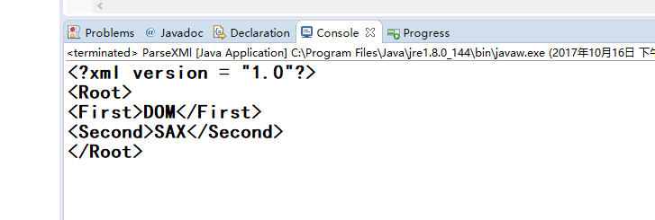

2.java的·源代码为：

package XmlAnalysis;

import javax.xml.parsers.DocumentBuilder;

import javax.xml.parsers.DocumentBuilderFactory;

import javax.xml.transform.Transformer;

import javax.xml.transform.TransformerFactory;

import javax.xml.transform.dom.DOMSource;

import javax.xml.transform.stream.StreamResult;

import org.w3c.dom.Attr;

import org.w3c.dom.Document;

import org.w3c.dom.Element;

public class Two {

public static void main(String[] args) {

try {

DocumentBuilderFactory factory = DocumentBuilderFactory.newInstance();

DocumentBuilder builder = factory.newDocumentBuilder();

Document doc = builder.newDocument();

Element team = doc.createElement("Team");

Element teamMember = doc.createElement("TeamMember");

Element empno = doc.createElement("Empno");

Attr empnoValue = doc.createAttribute("value");

empno.setAttribute(empnoValue.getNodeName(), "30772");

Element name = doc.createElement("Name");

Attr nameValue = doc.createAttribute("value");

name.setAttribute(nameValue.getNodeName(), "Manjeet Singh");

Element designation = doc.createElement("Designation");

Attr designationValue = doc.createAttribute("value");

designation.setAttribute(designationValue.getNodeName(), "Team Leader.");

team.appendChild(teamMember);

teamMember.appendChild(empno);

teamMember.appendChild(name);

teamMember.appendChild(designation);

doc.appendChild(team);

TransformerFactory tFactory = TransformerFactory.newInstance();

Transformer transformer = tFactory.newTransformer();

DOMSource source = new DOMSource(doc);

StreamResult result = new StreamResult(new java.io.File("Analysis.xml"));

transformer.transform(source, result);

} catch (Exception e) {

e.printStackTrace();

}

}

}

运行结果每当运行后在java项目的文件夹产生一个xml文件，文件名为：Analysis

